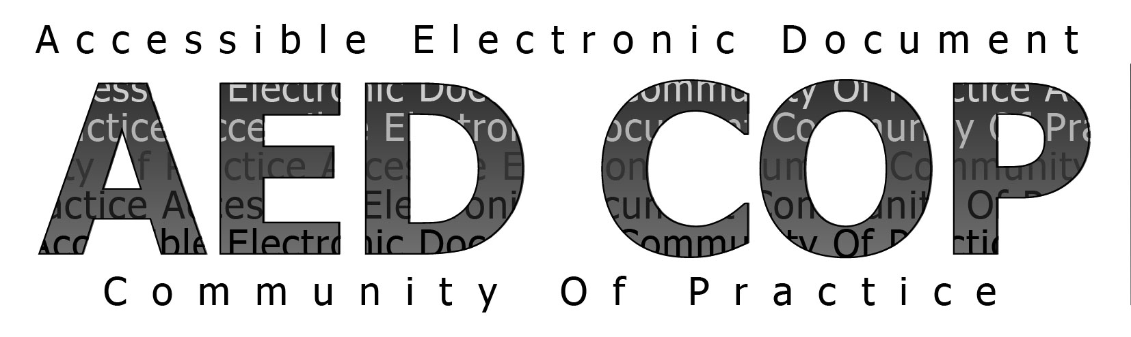

# Basic Authoring and Testing Checklist - MS WORD 2010 January 2015 Version 1.0

## Document

| **1 Did you save as a Word Document (.docx) with a descriptive filename?** | **Yes** | **No** |
| --- | --- | --- |
| The file type is Word 2010 document (.docx). |  |  |
| The filename identifies the document or its purpose. |  |  |

## Headings

| **2 Did you use styles to creat headings?** | **Yes** | **No** | **NA** |
| --- | --- | --- | --- |
| All headings appear in the Navigation Pane. |  |  |  |
| The navigation pane matches the visual outline of the document. |  |  |  |

## Lists

| **3 Did you use built-in features to create lists?** | **Yes** | **No** | **NA** |
| --- | --- | --- | --- |
| When lists are selected, built-in list features are highlighted on the Ribbon. |  |  |  |

## Columns

| **4 Did you use built-in columns to organize content?** | **Yes** | **No** | **NA** |
| --- | --- | --- | --- |
| For text in columns, Columns is listed under Section in the Reveal Formating Pane. |  |  |  |

## Layout Tables

| **5 Did you use built-in features to organize content in layout tables?** | **Yes** | **No** | **NA** |
| --- | --- | --- | --- |
| The tab order of layout tables matches the visual layout. |  |  |  |
| Text Wrapping is set to “None” in Table Properties. |  |  |  |

## Language

| **6 Did you identify distinct languages?** | **Yes** | **No** | **NA** |
| --- | --- | --- | --- |
| When text is in a different language, the correct language is identified. |  |  |  |

## Links

| **7 Did you create unambiguous names for links?** | **Yes** | **No** | **NA** |
| --- | --- | --- | --- |
| The destination, function or purpose is described in the link name or in surrounding text. |  |  |  |
| Links are uniquely identified. |  |  |  |

## Headers, Footers, and Watermarks

| **8 Did you duplicate vital information in headers, footers, and watermarks?** | **Yes** | **No** | **NA** |
| --- | --- | --- | --- |
| Vital information in headers, footers, and watermarks is duplicated at or near the start of the related information. |  |  |  |

## Data Tables

| **9 Did you use built-in features to create data tables?** | **Yes** | **No** | **NA** |
| --- | --- | --- | --- |
| When data tables are selected, the Table Tools Tab appears (and the Picture Tools Tab does not). |  |  |  |
| The table is simple; there are no merged or split cells. |  |  |  |
| There is only one row of headers. |  |  |  |
| The first row is set to “Repeat as Header Row.” |  |  |  |
| Text Wrapping is set to “None” in Table Properties. |  |  |  |

## Images and Other Objects

| **10 Did you create accessible images and other objects?** | **Yes** | **No** | **NA** |
| --- | --- | --- | --- |
| There is descriptive text in the Alt-Text, Caption, surrounding text or appendix. |  |  |  |
| The descriptive text on images of text matches verbatim. |  |  |  |
| “Double-quote, space, double-quote” has been entered for decorative objects. |  |  |  |
| There are no meaningful images reported under “Object not In Line” in the Accessibility Checker. |  |  |  |

## Text Boxes

| **11 Did you create accessible text boxes?** | **Yes** | **No** | **NA** |
| --- | --- | --- | --- |
| There are no Text Boxes under “Object not In Line” in the Accessibility Checker. |  |  |  |

## Color and Sensory Characteristics

| **12 Did you use color (and other sensory characteristics) plus text to convey meaning?** | **Yes** | **No** | **NA** |
| --- | --- | --- | --- |
| The meaning of color or other sensory characteristics is duplicated in text. |  |  |  |

## Color Contrast

| **13 Did you create the required color contrast?** | **Yes** | **No** | **NA** |
| --- | --- | --- | --- |
| Text and Large Text (including images of text, excluding logos) pass with the Color Contrast Analyzer. |  |  |  |

## Audio, Video, and Multimedia

| **14 Did you create accessible embeded files?** | **Yes** | **No** | **NA** |
| --- | --- | --- | --- |
| Audio-only content has an accurate and complete transcript. |  |  |  |
| Video-only content has an accurate and complete description. |  |  |  |
| Multimedia has accurate and complete synchronized captions. |  |  |  |
| Multimedia has accurate and complete synchronized audio descriptions. |  |  |  |

## Forms

| **15 Did you avoid forms?** | **Yes** | **No** |
| --- | --- | --- |
| Fillable form fields are excluded from the document. |  |  |

## Flashing Objects

| **16 Did you exclude flashing objects?** | **Yes** | **No** |
| --- | --- | --- |
| Flashing objects are excluded from the document. |  |  |

## Alternative Accessible Version

| **17 Did you provide an alternative accessible version?** | **Yes** | **No** | **NA** |
| --- | --- | --- | --- |
| An alternate version is provided and the information is equivalent and up to date with the primary document. |  |  |  |